**Smart Irrigation System**

**Problem:**

Irrigating fields plays a vital role in crop yield. However, how much and when to irrigate is still moderated by the traditional knowledge for the farmers. Knowing how much water is actually required for a given crop for a particular soil type depends majorly on soil’s capacity to hold moisture. We need an IoT, AI based solution which can auto irrigate the fields for a given crop based on the soil moisture content.

**Need for the solution:**

* Farming accounts for 70 percent of the water consumed and most of its wasteful use. Farmers are central to the whole picture an they are where most of the world's poverty is concentrated.
* Agriculture cannot be ignored in the water equation, it is the most important part of the developing world.
* A country like India with a tropical climate spread in disparity amoung its diverse land types, today experiences an ambiguous rainfall pattern which is a major source of irrigation the farmers have to rely on.
* The state's estimated irrigation potential is 5.1 million hectares of which 3.1 million hectares is already achieved. The gap of 2 million hectares cannot be fully addressed by ground water which is fully exploited.

**Solution:**

* Our model is responsible for obtaining data regarding the location, time and weather conditions (most prominently rain) and automate the working of irrigation system according to the moisture content of the soil at required intervals in a day.
* The model facilitates agility while working with varied soil types, crop variants in different weather conditions and seasons.
* All of this is done while keeping in mind its feasibility to farmers even in the remote areas.
* It is designed to take advantage of soil moisture sensors, humity, temperature and rain sensors to provide a smart watering system for users with an existing sprinkler system. All watering activities will be governed by a smart controller which will be able to collect information and allow the user to adjust watering amounts and times based on those readings.
* Our smart controller integrates seamlessly into the user’s existing sprinkler system to allow users to remotely control and monitor their home’s irrigation through a web interface or an android interface.
* The data collected by sensors is sent to the database created on the cloud for further processing and future weather condition prediction purposes.

Features and Functions :

Our product will consist of a central control unit, sensors, a web application, an android application, a cloud server which work and communicate effectively with each other.

**Sensor Readings**: The sensors monitor soil moisture, humidity, temperature levels in the user’s farm and sends the information to the central control unit. This data is processed by the controller in the control unit and uploaded, via the internet, to the cloud web server.

**Web Services:** It utilizes a web server to store all readings from the microcontroller into a database. These readings are then analyzed to determine what water amounts the lawn requires and allows the user to adjust their watering schedules accordingly.

**Remote Control:** It is used to monitor and control the irrigation system from a computer or smart phone. This application will provide control features to adjust watering schedules, soil and crop specification, read and record data collected by the sensors. This will allow the user to maintain complete control over their irrigation system regardless of their physical location.

**Scheduling:** Users will be able to create and change watering schedules via the web application. In addition to automated scheduling, users will be able to manually set or change schedules based on personal preferences or to adhere to local community water restrictions.

**Local Weather Analysis: T**o optimize water usage, the system will not operate when it is raining at the location. This information will be transferred between the rain sensor and the central control unit to override any scheduled watering that occurs while it is raining.

**Registration and Account Management:** To ensure the integrity of our system, each user must create an account and register themselves before being able to access the features of the web and android application. Each HICS device will be given a unique serial number that will be used for registration purposes. Once the user creates an account and registers their device they will be granted full access to interface with their device via the web application.

**Cloud database server:** The database has been created on AWS, this database stores the users value for signup and authentication and also the data from sensors. The website to facilitate efficient login and maneuvering is also hosted on the cloud.

SENSORS USED:

* DHT11: Humidity and temperature
* Soil Sensor: To detect soil moisture content
* Rain sensor: To detect rain

ARDUINO BASED:

* A cheaper, more affordable option.
* Used to obtain readings from the sensors, and execute simpler programs such as, detect when crops need water and execute a program and initiate/regulate irrigation mechanism.

RASPBERRY PI BASED:

* More technologically advanced model.
* Supports use of google weather-api to predict weather for the next few days, this doesn't just automates the model but also makes it smart.

PROJECT FLOW:

Initialize motor program

monitor rain, monitor tank level

**Water sensor**

Provide soil moisture content (0-1023)

Soil hyg. meter

Provide temp and humidity

**DHT11**

Initialize microcontroller, lcd, programs

Data acquisition

Start

Obtain date and time

STOP

Hardware requirements:

1. **Arduino UNO R3**

Arduino Uno is a microcontroller board based. It has 14 digital input/output pins (of which 6 can be used as PWM outputs), 6 analog inputs, a 16 MHz quartz crystal, a USB connection, a power jack, an ICSP header and a reset button. It contains everything needed to support the microcontroller; simply connect it to a computer with a USB cable or power it with a AC-to-DC adapter or battery to get started.

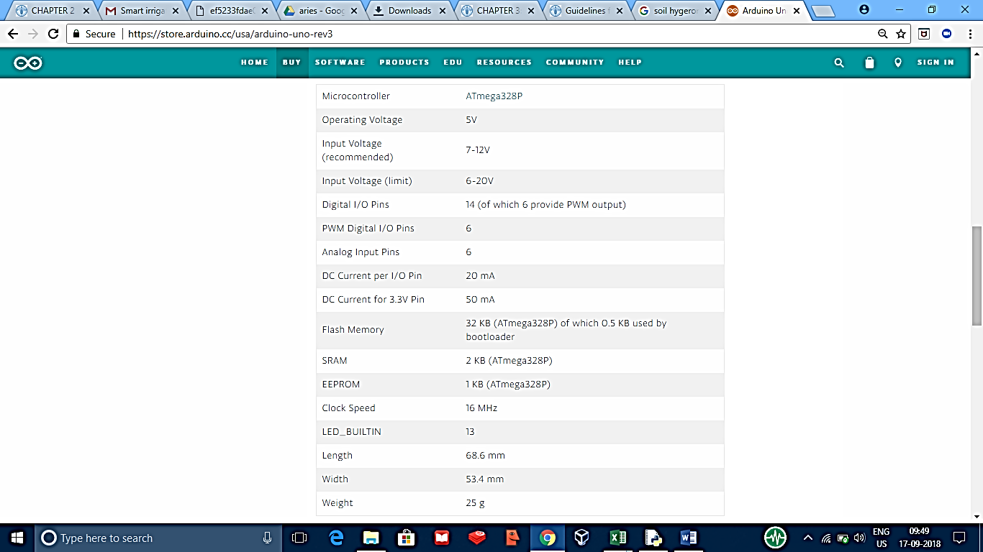

1. **DHT 11:**

DHT11 digital temperature and humidity sensor is a composite Sensor contains a calibrated digital signal output of the temperature and humidity. Application of a dedicated digital modules collection technology and the temperature and humidity sensing technology, to ensure that the product has high reliability and excellent long-term stability. The sensor includes a resistive sense of wet components and an NTC temperature measurement devices, and connected with a high-performance 8-bit microcontroller.

Applications:

HVAC, dehumidifier, testing and inspection equipment, consumer goods, automotive, automatic control, data loggers, weather stations, home appliances, humidity regulator, medical and other humidity measurement and control.

Features:

Low cost, long-term stability, relative humidity and temperature measurement, excellent quality, fast response, strong anti-interference ability, long distance signal transmission, digital signal output, and precise calibration.

Product parameters:

Relative humidity Resolution: 16Bit Repeatability: ±1% RH Accuracy: At 25℃ ±5% RH Interchangeability: fully interchangeable Response time: 1 / e (63%) of 25℃ 6s 1m / s air 6s.

1. **Soil sensor**

Specification:

* Operating voltage: 3.3V~5V
* Dual output mode, analog output more accurate
* With power indicator (red) and digital switching output indicator (green)
* Having LM393 comparator chip, stable
* Panel PCB Dimension: Approx.3cm x 1.5cm
* Soil Probe Dimension: Approx. 6cm x 3cm
* Cable Length: Approx.21cm
* VCC: 3.3V-5V
* GND: GND
* DO: digital output interface(0 and 1)
* AO: analog output interface

1. **Lcd (16*2)**

|  |  |  |
| --- | --- | --- |
| **Pin No** | **Function** | **Name** |
| 1 | Ground (0V) | Ground |
| 2 | Supply voltage; 5V (4.7V – 5.3V) | Vcc |
| 3 | Contrast adjustment; through a variable resistor | VEE |
| 4 | Selects command register when low; and data register when high | Register Select |
| 5 | Low to write to the register; High to read from the register | Read/write |
| 6 | Sends data to data pins when a high to low pulse is given | Enable |
| 7 | 8-bit data pins | DB0 |
| 8 | DB1 |
| 9 | DB2 |
| 10 | DB3 |
| 11 | DB4 |
| 12 | DB5 |
| 13 | DB6 |
| 14 | DB7 |
| 15 | Backlight VCC (5V) | Led+ |
| 16 | Backlight Ground (0V) | Led- |

1. **Relay (220V)**

Relay is an electrical switch using electrical signal to turn on/off the current. It is also used to control a circuit by a low-power signal.

On its body, you can see these characters and numbers:

* 10A 250VAC.
* 10A 125VAC.
* 10A 30VDC.
* 10A 28VDC.
* SRD-05VDC-SL-C.

This is what they mean:

* 10A 250VAC: The max current intensity of connection, where voltage is equal or less than 250V (AC), is 10A.
* SRD-05VDC-SL-C: Voltage of signal to control circuit is 5V.

1. **RTC IC – DS1307:**

[The DS1307 real time clock](http://www.edgefxkits.com/programmable-load-shedding-time-management-for-utility-department) (RTC) IC is an 8 pin device using an I2C interface. The DS1307 is a low-power clock/calendar with 56 bytes of battery backup SRAM. The clock/calendar provides seconds, minutes, hours, day, date, month and year qualified data. The end date of each month is automatically adjusted, especially for months with less than 31 days.

They are available as integrated circuits (ICs) and supervise timing like a clock and also operate date like a calendar. The main advantage of RTC is that they have an arrangement of battery backup which keeps the clock/calendar running even if there is power failure. An exceptionally little current is required for keeping the RTC animated. We can find these RTCs in many applications like embedded systems and computer mother boards, etc. In this article we are going to see about one of the real time clock (RTC), i.e. DS1307.

1. **Water sensor (fuduino):**

It can be used to detect the presence or absence of water, accurately gauge the water surface level, or you can even accurately gauge the volume of water present by using a volume measurement device such as a measuring cup in conjunction with the analog water sensor module. This makes it the Funduino analog water sensor a versatile component!

1. **Bread boards (x2)**
2. **Batteries 1.5V (x2)**
3. **Jumper wires**
4. **Development board**
5. **Raspberry pi 3 model B:**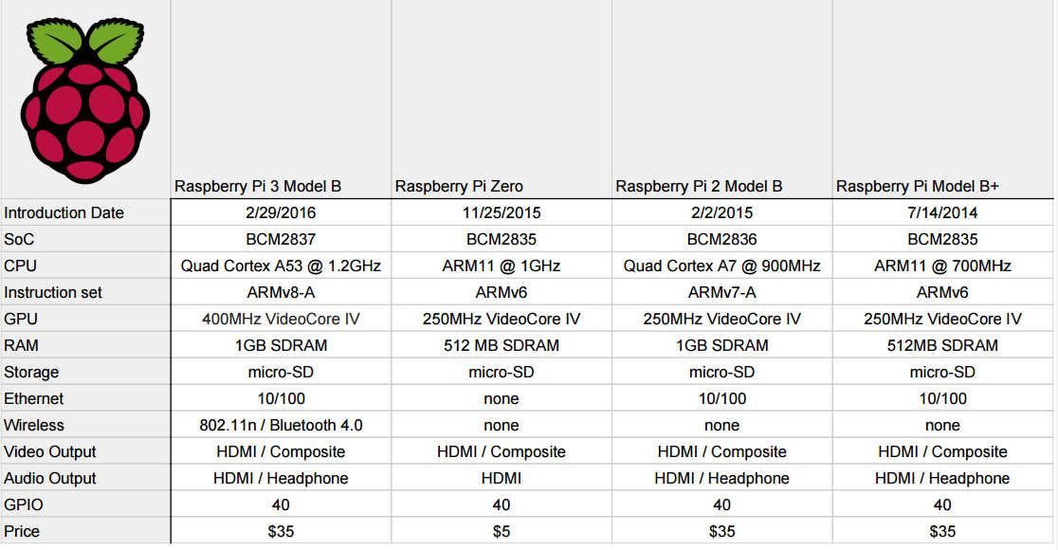

**CROP WATER EQUIREMENTS:**

**Blaney-Criddle Method**

|  |
| --- |
| **The Blaney-Criddle formula: ETo = p (0.46 T mean +8)** |

ETo = Reference crop evapotranspiration (mm/day) as an average for a period of 1 month  
T mean = mean daily temperature (°C)  
p = mean daily percentage of annual daytime hours

**ADVANTAGES OF THE MODEL:**

* This system proves to be cost effective and proficient in conserving water and reducing its wastage.
* This technology is a valuable tool for conserving water planning and irrigation scheduling.
* This system allows controlling the amount of water delivered to the crops when it is needed based on types of crops by monitoring soil moisture and temperature.

**FUTURE SCOPE:**

* A water meter can be installed to estimate the amount of water used for irrigation and thus giving a cost estimation.
* Division of our field in zones to monitor water distribution in each part of the field, this can be done using valves and using similar group of sensors at each valve.

RESOUCES:

http://www.fao.org/docrep/S2022E/s2022e07.htm